**Internationalised Industry-University Partnerships for Job-creating Graduates**

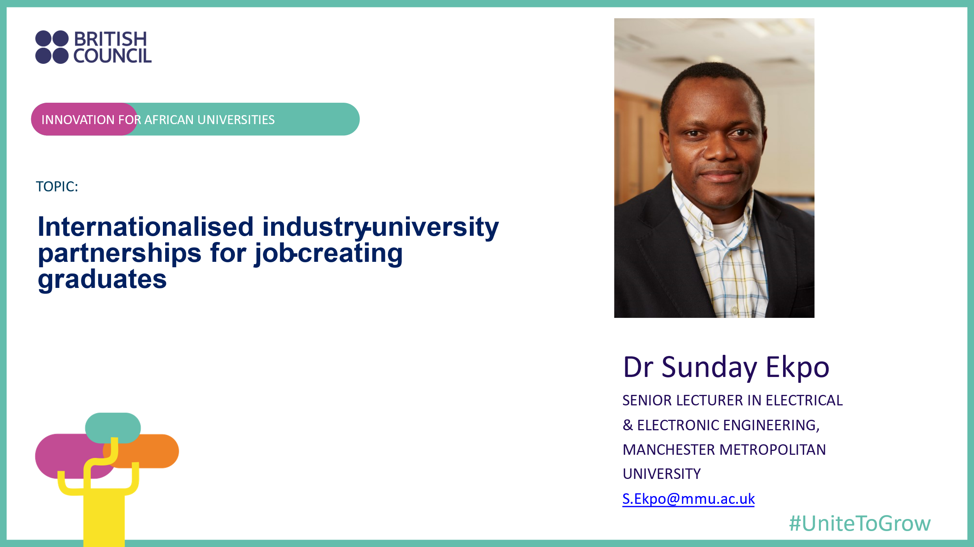

***Abstract*:** Unemployment is a global challenge. Low Science, Technology, Engineering and Mathematics (STEM) education and entrepreneurship uptake amongst women; digital skill-shortage vacancies; and low enterprise creation need a holistic global partnership to overcome them. It is time for engineering inclusive economies especially for the global south. The internationalised inclusive industry-linked STEM education concept offers a means through which all students can learn STEM subjects, digital and soft skills and incubate their innovative ideas to become industry-ready and technopreneurs. A holistic academe-industry partnership is needed to produce job-creating graduates and enhance graduate employability and entrepreneurship leadership. The British Council has utilised the Innovation for African Universities (IAU) programme to champion the world’s first and largest inclusive Enterprise Education and Industry-University innovation partnerships in the sub-Sahara African (SSA) continent. The funded 35 life-transforming projects involved 87 institutions and 389 network partners and project team members. At least 7000 lives were positively impacted in 54 supranational countries spanning five economic zones of the SSA. A funded Community of Practice project was on an internationalised inclusive blended industry-linked innovation incubation infrastructure capacity at a University campus. Technology was harnessed to innovate business ideas to simulate employment creation. Internationalised industry-University partnership scales across other African countries.

**Introduction**

The prevailing deflating global economic environment has occasioned the sub-Sahara African continent’s drive to develop and strengthen sustainable ecosystem elements for an internationalised innovative knowledge-based economy. Moreover, most SSA countries lack technology-driven local industries to stimulate industry-University education programmes partnerships. Hence, the British Council funded 24 collaboration and 11 community-building projects under the IAU programme 2021/2022. The design-thinking scoping / problem understanding activities (Phase 1) occurred mainly online whilst the solutions implementation (Phase 2) was a blended (online and onsite) approach. The IAU programme enabled the author to find that “**20 % of the unemployment causes contribute to 80 % of the young graduates’ problems**” whilst “**20 % of the non-entrepreneurship causes contribute to 80 % of the innovation incubation problems**.” Consequently, the potential impact of the IAU programme project(s) was envisaged to include sustainable employment for all; and provision of open research data on internationalised industry-University education programme model for **innovation incubation** for pan-SSA Governments and academic institutions to adopt, adapt and replicate.

At the *Association of International Education Administrators Annual Conference* (held in Washington DC, USA in February 2023), the British Council team was able to demonstrate to the world that the IAU programme’s internationalised industry-University partnerships model addresses multiple global educational and graduates outcomes challenges, viz: Enhancing and Expanding International Opportunities through Virtual Education; Building a Structure of Programmes and Tools for Students to Develop and Demonstrate Global Competence to Future Employers; Achieving Comprehensive Internationalization with National Government Programmes; Enhancing International Education for Equitable Learner Success; and Establishing a Globally Competitive International Education in the Global South. Thus, the IAU programme enables all economies to collaborate.

**From Job-Seeker/Seeking to Job-Creator/Creating**

According to the Statistics South Africa (STATSA, 15 May 2019), the burden of graduate unemployment is concentrated amongst the youths (aged 15–34 years). They account for 63.4 % of the total number of unemployed persons (with young University graduates comprising the 14 % of the 48.8 % participating in the labour market). Using this unemployment rate as the ceiling benchmark for the SSA countries demonstrates a compelling reason for internationalised University-industry linkages to promote employable and job-creating graduates (Ekpo, 2020; and Kitagaana, 2018). The internationalised inclusive enterprise education and industry-University programmes partnership concept offers a means through which all students can convert their innovative ideas to commercially viable and sustainable start-ups. This translates into their offering job opportunities for themselves and/or to their peers.

**Industry-University Partnerships**

The barriers to establishing sustainable blended inclusive industry-linked STEM Education, Innovation Incubation and Entrepreneurship / Technopreneurship Centres across the SSA also impede sustainable commercialisation and entrepreneurial leadership pan-Africa. It is time to strengthen the elements of the higher education institutions (HEI) ecosystem to develop a platform for innovation and creativity towards accelerated graduate employability and economic growth in the SSA countries, regions and economic zones (Ekpo, 2020; and Ameh & Okpa, 2018). Effective September 2015, the author has been developing an internationalised inclusive hybrid industry-linked engineering education programme model (with colleagues’ support at the Manchester Met University, UK) that showcases industry partners co-designing and co-delivering specialist contents online and in-person; and innovative student projects presentations to the relevant industry partners (Fig. 1). **Hybrid learning**, embraced by 76% of the students (Times Higher Education, 2022), was adopted in both cases to reflect the **modern workplace** and mimic the **future work experience** than learning entirely in-person. The IAU project (Business Innovation and Incubation Centre) adopted and adapted this industry-University education programme model.

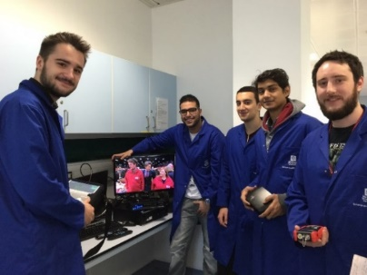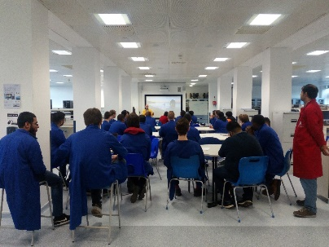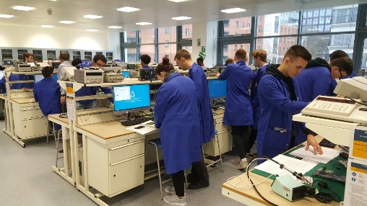

Figure 1. Industry-linked Education Programme

**Internationalised Education**

There is a transgenerational graduate education and achievements gulf between the global north and the global south. To halt and eliminate this widening gap, HEIs in the SSA need an internationalised inclusive blended industry-linked education programmes infrastructure / resources as a combined innovation and entrepreneurship and/or technopreneurship capacity building initiative integrated into the undergraduate, postgraduate and graduate education. This would create a platform for inter-transcontinental collaborative innovation and creativity towards accelerated inclusive demographic and geographic economic growth in the SSA and beyond.

**Global Citizenship through Industry-enhanced Employment / Employability / Enterprise**

Figure 2. Inclusive Industry-linked IAU Project

Considering the 4IR and women entrepreneurship, an internationalised industry-University education programme improves an employability development infrastructure capacity to drive sustainable inclusive youth-founded enterprises and entrepreneurs / technopreneurs support in collaboration with their global peers (Fig. 2) (Kitagaana, 2018; Ekpo, 2020; and Ezepue & Ochinanwata, 2017). Here, shared proprietary and open technologies are harnessed to innovate and incubate business ideas to create start-ups and/or employment in the SSA and beyond. This initiative should be driven by industry-linked research and development; business creation; technopreneurship; and technology transfer to facilitate institutional capacity building and improve graduate outcomes (e.g., employability, employment and enterprise) for inclusive growth, commercialisation and technopreneurial leadership.

Finally, internationalised inclusive industry-University partnership is beyond just the technology. Human factors remain critical. Internationalised skills development of job-creating graduates through an enhanced partnership between industry and University (education) must embrace digital transformation and tools. The benefits must be available and accessible to everyone in every community with no digital exclusion. This constitutes a unique reason why the British Council welcomes all to scale-up the benefits of the IAU programme across other African countries.

**ACKNOWLEDGEMENT**

The author wishes to thank the British Council for sponsoring this industry-university partnership research project under the Innovation for African Universities Programme 2021 of the Global Partnership Grants.

**REFERENCES**

[1] Ekpo, S. C., (2020). Industry-linked Projects and Research-informed-and-enriched Curriculum for Sustainable Student Employability Metrics, Journal of Higher Education Theory and Practice, 20, 3, 58–71.

[2] Kitagaana, Z., (2018), Constraints to University-Industry Linkage in Uganda: Perceptions of Dons at a Public University, African Journal of Education, Science and Technology, 5, 1, 140–147.

[3] Ameh, E. and Okpa, O. E., (2018), University-Industry Linkage and Graduate Employment in Cross River State, Nigeria, International Journal of Educational Research and Management Technology, 3, 2, 104–112.

*******Dr Sunday Cookey Ekpo is a Senior Lecturer in Electrical & Electronic Engineering, Manchester Metropolitan University, UK with 15+ years of combined industry-linked higher education research and teaching experience. He is a Senior Member of the Institute of Electrical & Electronic Engineering, USA; Senior Fellow of the Higher Education Academy, UK; Engineering and Physical Sciences Research Council Peer Review College Member, UK; UK Research and Innovation Talent Panel College Member; and Chartered Engineer with experience of providing niche expert research and development engineering inputs to world-leading companies spanning radio frequency communication engineering to satellite broadcast solutions manufacturing. Dr Ekpo’s education research interests span inclusive industry-linked engineering pedagogy; blended learning; and technology-enhanced hybrid pedagogy. Sunday is a recipient of several prestigious awards including the British Council grants for Innovation for African Universities; and the University Staff Development Programme for South African Academics.*