**Innovation for African Universities (IAU)**

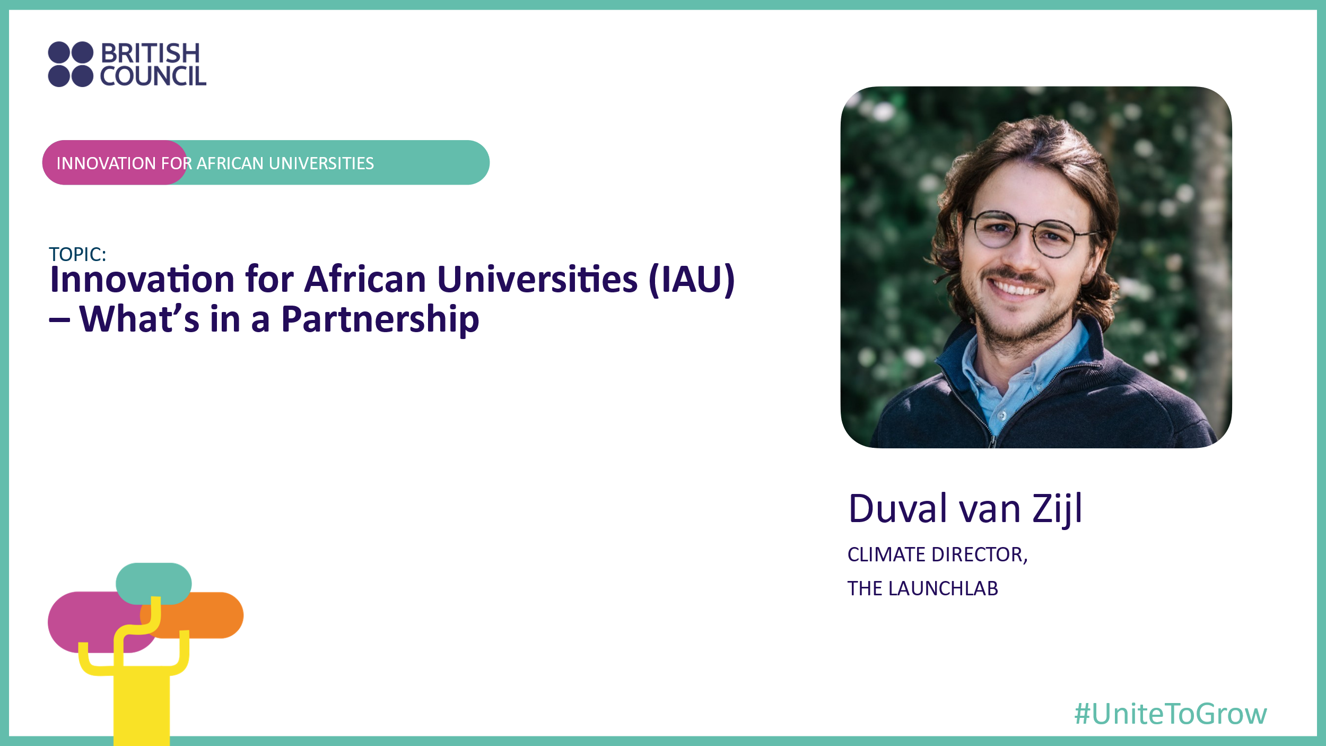

The AIEA Conference was a big success for the traveling IAU delegation, with our session on *“The Role of Internationalization in Strengthening University Entrepreneurship Ecosystems”* being well received by our audience.

As part of the session, I had the opportunity to present the ClimateLab, a climate accelerator launched in 2021/2022 together with our partner Coventry University, with the support of the British Council. At the conclusion of the presentation, I provided some recommendations on the key learnings in setting up and building effective international partnerships - a theme that ended up being prevalent throughout the conference.

In the spirit of collaboration and learning, this piece aims to coalesce not only my recommendations, but also some of the other sessions at the conference, particularly the aptly named session led by Susan Sutton (Indiana University) on *“Confusion and Opportunity: Exploring the Many Meanings of Partnerships”.*

Drawing inspiration from Leo Tolstoy’s famous quote, *“All happy families are alike; each unhappy family is unhappy in its own way”*, I’ve identified the key ingredients for any successful (happy) international partnership:

1. **Shared mission, values and goals:** Any partnership not founded on a shared mission/objectives/goals/values are doomed from the start. This is the cornerstone of any successful relationship, and without this there is no foundation to build on.
2. **Clarifying value propositions and roles:** In my presentation I called this the “stock take” phase (being a qualified accountant). Often time roles and responsibilities are allocated based on arbitrary criteria. For a partnership to truly be successful, it is imperative that each partner’s strengths be identified at the start and leveraged throughout the engagement. This is nothing different than Adam Smith’s fundamental economic concept of the “Division of Labour”.
3. **Open mindedness and collaboration:** The complexity of cultures, personalities, inherent bias, and prejudices come into the fray when international partnerships are being developed. Especially if the partnerships combine *Global North* and *Global South* partners (although the classifications are not a perfect description, they provide the necessary context). The only way in which to counter these biases is to come at the partnership with a spirit of collaboration, a want to understand your partner, and a willingness to explore new ways of working together.
4. **Time:** Any successful partnership takes time. Too often parties try to force collaboration in the short run due to various factors**:** reporting framework, project deadlines, incentives, etc.However, there are very few shortcuts when trying to build lasting and sustainable long-term partnerships.It’sbest to take a long-term view from the start, the reverse can be detrimental**.**
5. **Accountability and reporting:** Governance of a partnership relationship is of critical importance. In many cases executing partners are not beholden to external scrutiny, which inevitably leads to suboptimal outcomes.Putting accountability and reporting structures in place at the start, monitored by independent parties, can help ensure that partnerships stay on course.
6. **Trust:** Trust ispotentially one of the trickiest elements when forming a new partnership with a counterparty that your institution has not engaged with previously. There is a principle in marriage called the *Magic Ratio, that* states “that for every negative interaction during conflict, a stable and happy marriage has five (or more) positive interactions”. Unfortunately, at the outset of a partnership, you might not have the opportunity to build up to this ratio, but none the less this needs to remain embedded in the partnership’ ethos. Principle 1 – 5 helps to alleviate concerns around partnership trust at an early stage, as partners will get early data points and criteria to use prior to locking into a long-term relationship.

Although the above is ostensibly simple - it’s anything but - as aligning on shared goals and deeply empathising and understanding your partner are no simple tasks.

**I’d like to leave the reader with a couple of open-ended questions to ponder:**

* How does one do a proper “stock take” to ensure that the real strength of each partner is identified? And, should one also do the same for potential weaknesses?
* How do you build trust and empathy in an environment where various types of social cues are not available, particularly with reference to a remote / hybrid type of partnerships?
* What are the ways in which partners can test for shared values during initial interactions?
* What would the partnership look like if there was no money involved, but only a shared objective? *(Note: This was posed by a participant during one of the AIEA sessions)*

**Special thanks** to my fellow IAU delegations who acted as co-conspirators in synethising my thoughts on the topic.